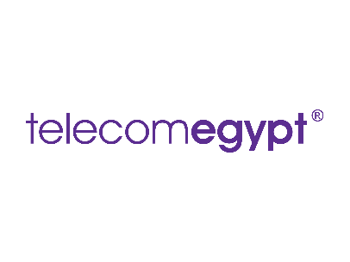

SPM Risk Management Plan

|  |  |  |
| --- | --- | --- |
| **Author:** Project Manager  **Status:** Draft / Final | **Created:** November 15  **Updated:** November 15 |  |

# Objective

The objective of this document is to outline the risks to the HVAC installation and office renovation project and the plans to mitigate those risks.

Executive Summary

Telecom Egypt aims to improve energy efficiency and working conditions through multiple initiatives: Upgrading HVAC systems in cable landing stations (Abt, Eldars). Implementing the PUE metric to enhance power consumption awareness. Renovating of basement offices to improve ventilation, lighting, and furniture quality. Conducting leadership training workshops for employees in supervisory positions.

**RISK TYPE ONE: You are at risk of going over budget**

|  |  |  |
| --- | --- | --- |
| **Scenario** | **Risk to Project** | **Mitigation Plan** |
| A vendor provides higher-than-expected quotes for the HVAC systems | **Medium** | **Obtain multiple vendor quotes, negotiate, and adjust the project scope if necessary** |
| Renovation of basement offices exceeds planned costs | **Medium** | **Ensure clear specifications for contractors and monitor costs closely** |
| Delays in procurement of PUE metric systems | **Low** | **Ensure timely planning and allocation of company resources for the PUE metric implementation** |
| Training workshops take longer than expected due to employee availability | **Medium** | **Schedule workshops early and ensure flexible timing options to avoid delays** |

**RISK TYPE TWO: Project timeline risks**

|  |  |  |
| --- | --- | --- |
| **Scenario** | **Risk to project** | **Mitigation Plan** |
| Installation of HVAC systems faces unexpected technical issues | **High** | **Have technical experts on standby for troubleshooting during the installation phase** |
| Office renovation encounters unexpected structural challenges | **Medium** | **Perform detailed site inspections and involve expert contractors** |
| PUE metric data collection tools face configuration issues | **Medium** | **Test tools in a controlled environment before full implementation** |
| Training workshops do not achieve desired impact | **Low** | **Conduct feedback sessions post-training and provide follow-up resources** |